Is It Necessary to Thaw PBMCs in Their Expanding Media?

Posted by Luke Doiron on Jun 23, 2015 2:45:37 PM

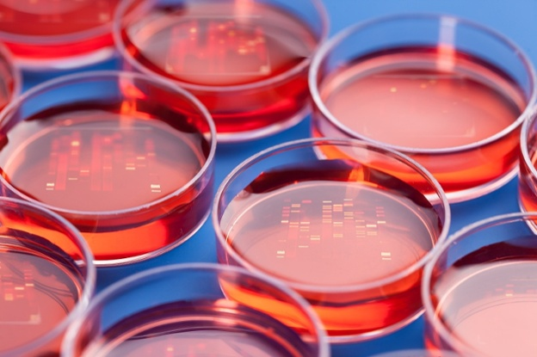
Scientists conducting research in a wide variety of fields, including immunology,infectious diseases, stem cells, cancer, drug development, vaccine development, transplant immunology and cell-based assays often turn to PBMC specimens. Thousands of cryopreserved PBMC specimens are available in biobanks around the world, making them an important source for researchers. Fortunately, it's been found that cryopreserved PBMCs are useful and valid specimens as long as they are properly handled.
Because PBMCs are the 'launching' specimen for so many important downstream research and therapeutic protocols, it is absolutely imperative that they are properly collected, isolated, cryopreserved, and thawed. Optimizing and standardizing the proper thawing technique ensures that your PBMCs provide valid and accurate data which doesn't compromise your research programs.
One common question concerns what type of media is necessary for thawing and expanding PBMCs. The basic answer is -- it depends on your ultimate application. In general, it is OK to use a variety of media to thaw PBMCs, but you run the risk of incurring changes in growth factors and other accessory metabolites.

Here is one common thawing media:
- RPMI 1640 media with L-Glutamine and 25mM HEPES
- 10% fetal bovine serum (FBS)
- 1% L-glutamine
- 50 µg/ml Gentamicin
This lengthy study from the Immunology of Diabetes Society T-Cell Workshop Committee set out to establish the best practices for handling PBMCs so as to generate viable samples for T-cell assays. As regards PBMC thawing protocols, authors concluded that, "It is common laboratory practice to thaw cryopreserved PBMCs rapidly by transferring them directly from liquid nitrogen to 37°C, while promptly diluting and washing away the DMSO-containing freezing solution with pre-warmed medium. As for freezing, the rationale is to minimize osmotic variations likely to occur with slow thawing, and to avoid the toxic effects of DMSO. The study from Disis et al.supports this practice: when the thawing medium was pre-cooled to 4°C, mean viability was 69·7% compared to 92·5% at 25°C and to 95·1% at 37°C."

Variations regarding the best method for thawing PBMCs can be found throughout literature; however, this simple protocol is often followed:
- Place vial of cells in 37°C water bath and agitate until thawed. It's very important to thaw cells quickly; do NOT allow thawed cells to remain in freezing media any longer than necessary.
- Slowly add thawed cells to 9 ml of medium. Invert tube two or three times to mix or mix gently by pipetting up and down several times.
- Centrifuge for 10 min at 200 x g.
- Decant or aspirate supernatant and gently resuspend pellet in 10 ml of desired medium.
- Take an aliquot for cell count and proceed with your research protocol.
Important note: the cell suspension can sometimes form clumps after standing at room temperature. This can be avoided by preparing and using the cells promptly or by adding DNase to the suspension at a final concentration of 10 units per ml.
There is also a commercially-available system that claims to standardize the thawing process for each cryopreserved PBMC vial. The system uses a sensing technology which monitors vial temperature to detect solid-to-liquid phase change and therefore produce a standardized thawing procedure. When this method was compared to the standard 37°C water bath thaw method, the automatic technique provided higher mean viable-cell recoveries and a moderate increase in monocyte frequency, more consistent with that of freshly isolated cells.
At Conversant Bio, we have an extensive collection of biospecimens and solid expertise in providing our clients with a wide range of human peripheral blood specimens from normal donors and patients with cancer or autoimmune and inflammatory diseases.

